

Available at
www.ComputerScienceWeb.com
POWERED BY SCIENCE ^DIRECTComputer Networks 41 (2003) 475-487
www.elsevier.com/locate/comnet
A new class of QoS routing strategies based on network
graph reduction C. Casetti ⁸
^{q}
ª, R. Lo Cigno ª, M. Mellia ª, M. Munafo ^{a,}*,Z.Zs6ka ^{b}
ª Dipartimento di Elettronica, Politecnico di Torino, Corso Duca degli Abruzzi 24, I-10129 Torino, Italy ^{b} Department of Telecommunications, Budapest Universityof Technologyand Economics, Magyar tud6sok korutja 2,
1117 Budapest, Hungary
Received 15 October 2002; received in revised form 16 October 2002; accepted 24 October 2002
Responsible Editor: I.F. Akyildiz
Abstract
This paper discusses a new approach to QoS routing, introducing the notion of algorithm resilience (i.e., its capability to adapt to network and load modifications) as performance index of the algorithm itself.
The new approach can be summarized as Network Graph Reduction, i.e., a modification of the graph describing the network before the routing path is computed, in order to exclude from the path selection over-congested portions of the network. This solution leads to a class of two-step routing algorithms, where both steps are simple, hence allowing efficient implementation.
Simulation experiments, run on randomly-generated topologies and traffic patterns, show that these routing algorithms perform consistently better than both the standard Minimum Hop algorithm and those QoS-based algorithms based on the same metrics but not using the notion of Network Graph Reduction. © 2002 Elsevier Science B.V. All rights reserved.
Keywords: QoS routing; Routing algorithms; MPLS
1. Introduction
Dynamic, QoS-based routing received considerable attention in recent years [1-7], especially considering the difficulty in predicting Internet
This work was supported in part by the Italian Ministry for University and Scientific Research through the PLANET-IP Project. A preliminary version of this paper was presented at IEEE Infocom 2002 in New York.
Corresponding author.
E-mail address: munafo@polito.it (M. Munafo).
traffic patterns and the consequent impossibility to properly plan and dimension the network.
The core of any QoS-based routing algorithm is a network-status-dependent cost function that is used to find the optimal (or at least a suitable) route across the network by solving an optimization problem. In particular, given the best-effort nature of the current Internet where elastic data flows are in the majority, the most commonly used metric aims at the maximization of either network utilization or user throughput. Several proposals introduced cost functions, algorithms and protocols that give them advantages over traditional,
1389-1286/02/$ - see front matter © 2002 Elsevier Science B.V. All rights reserved. PII: S1389-1286(02)00414-0
topology-based algorithms such as the Minimum Hop (MH) ¹ presently used in TCP/IP networks [8,9]. For example in [1], the authors introduce the bottleneck bandwidth as a metric and then define the maximization of user throughput as optimization target. Similarly, in [2,3] the authors study how to improve the throughput of high-bandwidth traffic, such as large file transfers, in a network where resources are fairly shared among connections. Their findings, obtained by simulation, show that, at high loads, a MH routing algorithm maximizes network and user performance; for low-congested networks, instead, they propose an algorithm, named Minimum Distance (MD) routing, which offers better performance. However they are unable to provide an algorithm that merges the two behaviors. Researchers focused their attention upon other aspects of QoS routing, namely protocol overhead [5,7], implementation issues [4,6], impact of update policies [5].
A major drawback, however, affects all QoS-based routing algorithms. The cost function at the core of the algorithms tries to find portions of the network where resources are under-utilized and exploits them to the benefit of connections that would otherwise cross a congested portion of the network. In doing so, as shown in [11] for the case of simple alternate routing, the algorithm ends up consuming more resources than MH routing does, hence, in case of heavy congestion, QoS-based routing wastes resources and performs poorly compared with MH. A formal proof of this observation can be found in [10]. The extension of this property to TCP/IP networks is not straightforward, since flows often exhibit a greedy, elastic behavior, using up the available bandwidth. MH routing has been already conjectured to be asymptotically optimal as the load q offered to the network tends to infinity, and many simulation results confirm this intuition [2,3,13,16]. We stress at this point that the poor performance of QoS-based routing at high loads is not due to the sub-optimality of the used algorithms, but is rooted in the locality of the routing decision. Whenever a
¹ In this paper we refer to the MH algorithm as a special case of the Shortest Path, in which all links have unitary costs.
call is routed, the given cost function is minimized/ maximized for the current state of the network, necessarily disregarding the future network evolution. Under heavy load, the overall network benefit does not coincide with the cost function of a single call, hence the minimization of the one does not lead to the maximization of the other.
In the light of the above discussion, the drawback of QoS routing in the Internet is clear: whatever is gained at low or medium network loads, it is paid for at high network loads. What is needed to solve this problem is a resilient algorithm that allows the migration of a QoS-based routing algorithm to MH routing as q grows large. The problem is that q is typically not known to the routing algorithm, not even in the case of centralized routing algorithms.
The contribution of this paper lies in the identification and definition of a class of routing algorithms, named Network Graph Reduction (NGR), whose performance encompasses that of QoS-based routing algorithms at light and medium loads, and the optimality of MH routing at high loads. The goal is obtained by reducing the graph that describes the network topology, and applying a suitable metric to the reduced graph. Results are reported showing both the elementary properties of the algorithm, and its behavior in randomly generated topologies, both with uniform and non-uniform, time-varying traffic.
The rest of the paper is organized as follows. Section 2 provides a general description of the NGR algorithm, along with implementation issues. Section 3 presents the network and traffic models used in the simulation presented in Section 4, in which the performance of the NGR algorithm is compared to the one of classic QoS routing algorithms, both in simple network scenarios, and in more complex ones. Finally, conclusions and future work are discussed in Section 5.
2. NGR routing algorithms
Routing can be formalized as the problem of finding a suitable set of edges connecting two nodes in a directed graph. QoS routing relies on the definition of a suitable edge metric w, which depends on the networks status, and of a cost function c(-), which should be minimized/maximized, yielding the optimal route selection under specific network conditions. As discussed in the Introduction, however, all metrics and cost functions that try to maximize network utilization or/ and user throughput suffer from the same drawback: as the network load increases (q !oo) their performance drops below that of a simple MH algorithm. Finding metrics that let the path selection process converge to MH routing as q increases seems to be a hard problem. As shown in [16] the elastic nature of the Internet traffic just worsens the problem. The difficulty of finding a suitable metric lies in the fact that the goal of such a metric should change with the network load, making the problem not easily tackled by a standard minimization approach.
Indeed, we can look at the routing problem from a slightly modified perspective. Instead of trying to find adaptive metrics, the same metric that works well for light loads can be applied at high loads to a reduced graph that only contains uncongested links, i.e., links whose load is under a given threshold. Since the reduced graph may not be connected, i.e., no path may exist from a source to a destination, the minimum-hop path should always be included as possible solution of the routing problem. Thus, as the offered load q grows, all links become congested and the algorithm necessarily chooses the minimum-hop path. While the direct measure (or evaluation) of q is a complex task, the identification of single congested links is extremely easy, so that, overall, the methodology is simple and its implementation straightforward.
This key idea leads to the definition of the NGR strategy which can be applied to any existing QoS routing algorithms.
2.1. Formal description
For the purpose of providing a formal description of the class of NGR algorithms in their most general form, we use a standard graph theory formalism. Thus, we refer to a generic network as a directed graph G = (V, E), where V is the set of vertices (nodes, in our case), and E is the set of edges (links). A path p(v_{s}, v_{d}) of length n = \\p(v_{s}, v_{d})\\ is defined as a sequence of n distinct edges e; joining v_{s} and v_{d}, where v_{s}, v_{d} 2 V, e; 2 E, p(v_{s}, v_{d}) = {e!, e2,..., en}.
A set P_{G} is defined as the set of all paths existing between any two distinct vertices of G, i.e., Pg = {p(v_{s}, vd)\v_{s}, vd 2 V, v_{s} = vd}. Each link is assigned a weight w using any metric that combines topological, physical or traffic-related characteristics of that link. To each path p a cost c(p) is assigned using a combination of the weights of its links. Following this, an order relation -< in the set P_{G} is established among paths, and we will refer to a path p; as ''lighter than'' Pj if p; -< Pj holds.
The NGR algorithm operates two subsequent alterations upon the path set P_{G}, and applies selection criteria on the resulting subset:
• Step 1: the first alteration transforms the directed graph G into G' = (V, E'), E' C E, selecting only those links whose weight satisfies a Cut-off criterion C (e.g., if w represented the link capacity, ''slower'' links could be discarded from path selection if w < w_{M}, where w_{M} is the smallest acceptable capacity); as a result, the path set P_{G} is reduced to P_{G}' after removing those paths containing cut-off links;
• Step 2: let P_{mh} be the set including one minimum-hop path from each source to each destination. In case more than one minimum-hop path exist from the same source to the same destination, one at random is selected. ³ The second alteration transforms the path set PG into PG' = P_{G}' [ P_{mh}; the new subset is built from (i) the paths belonging to PG and (ii) the minimum-hop paths between any two nodes in V, even if their links were discarded in the first step.
Finally, the decision on how to route packets between a source and a destination is made by applying the order relation -< to the path subset of PG joining source and destination, and picking the path
² In this paper we interchangeably use the terms 'edges' and 'links' and the terms 'vertices' and 'nodes'.
³ It is possible to optimize the P_{mh} set, for example using load-balancing criteria.
that turns out to be the lightest according to the cost metric defined by the QoS routing algorithm.
2.2. NGR-MD and NGR-WS algorithms
In a broad sense the NGR methodology can be coupled with any metric and cost function. In order to exemplify this property, we considered the application of this methodology to two algorithms already proposed in the literature, which were shown to offer good performance [1,2]:
Widest-shortest (WS): for each source-destination pair, the algorithm determines all the paths with the minimum-hop count; if more than one such path exist, it breaks the tie by choosing the one with the largest available bandwidth [1]; Minimum distance (MD): for each source-destination pair, the path is chosen which minimizes the sum on each link of the inverse of the equal bandwidth share [2].
To help the reader, we report a simple description of the above algorithms, using the notation introduced in this paper.
• WS path weight computation: a weight w_{j} associated to a generic link J is computed as
wj = bj, (1)
where b_{J} is an estimate of the currently available bandwidth on link J;
The set of paths among which the path PG is chosen is restricted to the minimum-hop paths, i.e.,
Pg = {{p,(v_{s}, vd)\ \\p;(v_{s}, vd)\\ 6 \ \pj(vs, vd)\\ 8j}
8v_{s}, vd }. (2)
Then, the cost c(p;) of path p; is defined as follows:
c(p,-)= min {wj}; (3)
and the ordering relation is such that p, - pj if c(p;) > c(pj) (i.e., p; is lighter than Pj if its available bandwidth is larger than p/s).
• MD path weight computation: a weight wj associated to a generic link J is computed as
where C_{J} is the link capacity and n_{J} is an estimate of the number of active flows currently routed over link J.
The cost c(p_{l}) of path p_{t} is then defined as follows:
(5)
(4)
and the ordering relation is such that p, - pj if
^{c(p},⁾ < ^{c(p}jTo implement the NGR algorithms, we define the following:
Cut-off criterion C : a link is discarded if its utilization is found to be above a given threshold W, i.e.,
bj/cj > Wt. (6)
Combining NGR and C with either the MD or WS QoS algorithms we obtain the NGR-MD and NGR-WS algorithms.
In the rest of the paper, we assume Wt = 1, i.e., if a link shows a 100% utilization, it is discarded by the Cut-off criterion.
2.3. Implementation issues
After defining the algorithms, we are interested in the viability of a consistent hop-by-hop implementation, in which routing decisions taken at an upstream node are not liable to be superseded by downstream nodes finding a locally-optimal alternative to the path chosen earlier by upstream nodes. As formally proved in [12], the WS algorithm does not belong to the class of algorithms that allow a consistent hop-by-hop implementation, while the MD algorithm can be implemented in a hop-by-hop fashion while preserving consistency. If we combine the NGR methodology described above with those algorithms, is the hop-by-hop implementation property preserved? Unfortunately, the answer is negative. The proof in case of the NGR-MD metric is by counter-example, while NGR-WS cannot be considered since the WS criterion itself is not implementable hop-by-hop. Consider the simple directed graph in Fig. 1, consisting of five links, a, b, c, d, z, each labeled with its own weight, i.e., w_{a} = 10, w_{b} = 5, w_{c} = 2, w_{d} = 2 and w_{z} = 2. Let us consider the problem of
n, + 1
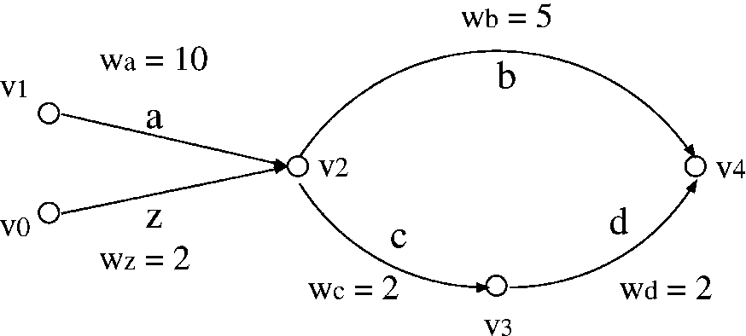
Fig. 1. Simple topology where the hop-by-hop implementation of the NGR algorithm fails.
routing a packet from v₁ to v₄ according to the NGR-MD criterion, locally implemented at each node. For the sake of simplicity, we consider v₄ as the only destination, such that only paths ending in v4 are listed in PG.
Let us suppose that, of all links, only link a, joining v₁ and v₂, does not make the cut at Step 1, being overloaded. As a consequence, the P_{G} path set is ({b}, {z, b}, {z, c, d}, {c, d}, {d}). Step 2, however, reintroduces path {a, b} because it is the minimum-hop path from v₁ to v₄. Therefore, we have P'_{G}' = p_{g}' [{a,b}. Since only one path joining v₁ and v₄ is available, such path is the natural choice to go from v₁ to v₄.
However, from v₂'s standpoint, the ordering is such that path {c, d} is lighter than path {b}.It follows that a packet reaching node v2 will travel over links c and d, and not over link b, as was originally meant by v₁.
This could happen every time a node along the path follows the congested links, so that, from that node on, the destination can be reached on the path set PG and not necessarily on the minimum-hop path only, i.e., p(v₁, v₄) is congested, while p(v2, v4) is not.
If we resorted to a hop-by-hop implementation of the NGR algorithm, one possible disadvantage is intuitively illustrated by considering paths (and connections) from v₀ to v₄, necessarily crossing link z. Let us suppose that link z is lightly loaded, and, therefore, that the choice of paths operated by v0 is consistent with forwarding operations by v2, i.e., connections are routed over the {z, c, d} path. At the same time, connections from v₁ to v₄ are also forwarded by v2 over {c, d}, for the reasons outlined above, thus overloading that path, and possibly leading to routing oscillations and performance degradation.
In the following, we will refer to a consistent version of the NGR algorithms if routing decisions taken at upstream nodes are not overruled by downstream nodes, while we will refer to a hop-by-hop version of NGR (NGR HbH) if every node implements its own locally-optimal version of the algorithm.
As pointed out above, for consistent routing to be preserved, the forwarding procedures of the NGR algorithm must be integrated so as to signal the routing decision taken at upstream nodes. This solution can be implemented using the route-pinning property of the MPLS technology [14], or a slight modification of the IP forwarding procedure.
2.3.1. MPLS implementation
If MPLS is used, each node can open a Label Switched Path (LSP) on the minimum-hop path toward each destination. Then, for each packet, the edge router selects whether to route it using the MPLS LSP, or using the classic hop-by-hop IP routing over the best path selected using the QoS routing algorithm. Potentially, a total number of N(N — 1) LSPs can be set up, where N is the number of routers in the domain.
Another possibility is to always have an LSP from each source to each destination, that can either be routed through the QoS path, or through the minimum-hop path in case no available QoS path exists. This simplifies the forwarding procedure at each node, but requires a larger amount of MPLS signalling, because the QoS paths are more frequently updated than the minimum-hop paths.
2.3.2. Classic IP implementation
If, on the other hand, standard IP forwarding is used, it is possible to have the edge router tag packets (e.g., by setting a bit in the TOS field of an IPv4 packet header) when they are supposed to travel along a minimum-hop path. This solution prevents downstream nodes from choosing locally-optimal paths.
By adding the above mentioned tag, the algorithm is implementable using OSPF or IS-IS. Each node has to compute and maintain two routing tables, the first for the minimum-hop paths, the second for the QoS-based routing information. In more detail:
• routers advertise QoS metrics for their outgoing links according to the selected algorithm, e.g., as computed by (3) or by (4);
• upon advertising them, routers mark links that fail the cut-off criterion;
• when compiling their routing table, routers run the minimum-hop algorithm with the usual 30-min periodicity, using unitary metrics for each link in the complete network graph; in this way, the minimum-hop paths towards any destination are identified;
• with smaller periodicity, they run the QoS algorithm, thus identifying the lightest path toward any destination;
• for each destination, a router stores next-hop entries associated to minimum-hop and to lightest paths.
Upon reception of a packet, a router should inspect its destination address and TOS field; if a match is found, the router will forward the packet toward the next hop on the lightest path, unless the packet is tagged, in which case the next hop in the minimum-hop path is chosen.
As a final remark, it should be noted that the asymptotic computational complexity of the NGR algorithms is the same as the complexity of the QoS algorithms without graph reduction.
3. Evaluating routing algorithms
The performance evaluation of routing algorithms is typically based on simulations. In this paper, we adopt a traffic model and performance evaluation tool, recently introduced in [15,16], that matches the characteristics and the dynamics of the Internet better than traditional connection-based simulation tools. Additional information about the tool itself, based on the ANCLES simulator, can be found in [15-17].
TCP/IP networks do not provide for connection admission control, hence there is no limitation on the number of concurrent connections on a given path. The dominant Internet applications (namely, all data-based applications over TCP) are elastic, adapting the transmission speed to the available resources. A connection is opened with a given amount of data to transfer and it is closed either when the transfer is complete, or when the user tires of waiting and drops the session or when it is reset. In other words, connection durations are not known in advance, but are determined by data file sizes and network conditions.
The evaluation tool we use takes the elastic model into account. Specifically:
• flows are characterized by a given amount of data to transfer;
• the amount of resources the flow can exploit at any given time is the minimum between a target bit rate for the flow, e.g., the access line speed, and what the flow would be assigned under perfect max-min fair resource sharing;
• the flow holding time depends on the resources it receives throughout its ''life,'' which determine the amount of data already transmitted at any given time;
• if the resources usable by a flow fall below a given threshold, the connection may be shut down prematurely, mimicking the behavior of impatient users.
The performance metrics we take into account are:
• the fraction of connections are shut down due to lack of resources;
• the average throughput of connections that complete the data transfer;
• the overall throughput of the network.
Further details about the traffic model and the evaluation methodology, as well as evidence of the difference between this approach and more traditional ones can be found in [15,16].
4. Algorithm performance and resilience
The algorithm described in Section 2 necessarily behaves as a MD or WS algorithm for uncongested networks and as a MH algorithm as the offered load increases causing congestion; however, the behavior at intermediate loads can only be investigated by simulation. For the sake of comparison, result reports include the classic MD, WS algorithms and the MH algorithms.
We separately consider two cases, analyzed in the following two Sections. The first one presents elementary results on a trivial topology, which can aid the understanding of the algorithms and verify that the algorithms behave as expected. The second one analyzes results in complex, randomly-generated topologies and different traffic patterns, ensuring that the properties of the algorithm are not bound by the choice of the topology or of the traffic pattern.
4.1. Elementarybehavior
We consider the transient behavior on a trivial tri-node topology as described in Fig. 2. Node v0 generates all the traffic which is directed to nodes v₁ and v₂. All links e_{t}j are unidirectional with capacity 1. v0 starts sending all connection requests to v₁, then progressively (and linearly) decreases the amount of traffic directed to v₁, increasing the fraction directed to v₂. Let 0 6 T₀₁61 and 0 6 T₀₂ 6 1 represent the fraction of the overall traffic routed from node v₀ to node v₁ and to node v₂ respectively. T₀₁ + T₀₂ = 1at any time. The resulting overall network offered traffic is constant and always set equal to 2.
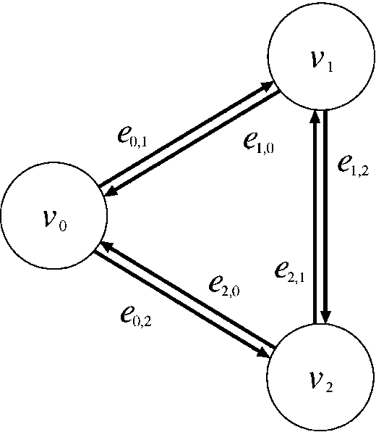
The behavior of MH in this simple case is obvious: the traffic fraction T₀₁ is always routed on link e₀₁ and the traffic fraction T₀₂ is always routed on link e₀₂. Notice that only when T_{0}1} = T₀₂ = 0.5 (in the example, when node v₀ is equally sending its traffic to node v₁ and v₂) does the MH algorithm manage to transport all the offered traffic. Otherwise, the ''widest'' connection is throttled on each corresponding link. Also note that, in this simple scenario, both the WS and the NGR-WS algorithms behave like MH, as only one minimum-hop path exists between any two nodes.
If either the MD or the NGR-MD algorithm is
used, the behavior is not so straightforward. Indeed, we expect that, when one of the traffic relations is idle, all available resources are devoted to the other, thus allowing to completely exploit the network capacity. In particular, links e₁₂ or e₂₁ should be used by part of the traffic from the active (non-idle) traffic relation.
Fig. 3 reports the free bandwidth on those links for the NGR-MD algorithm (lower plot) and
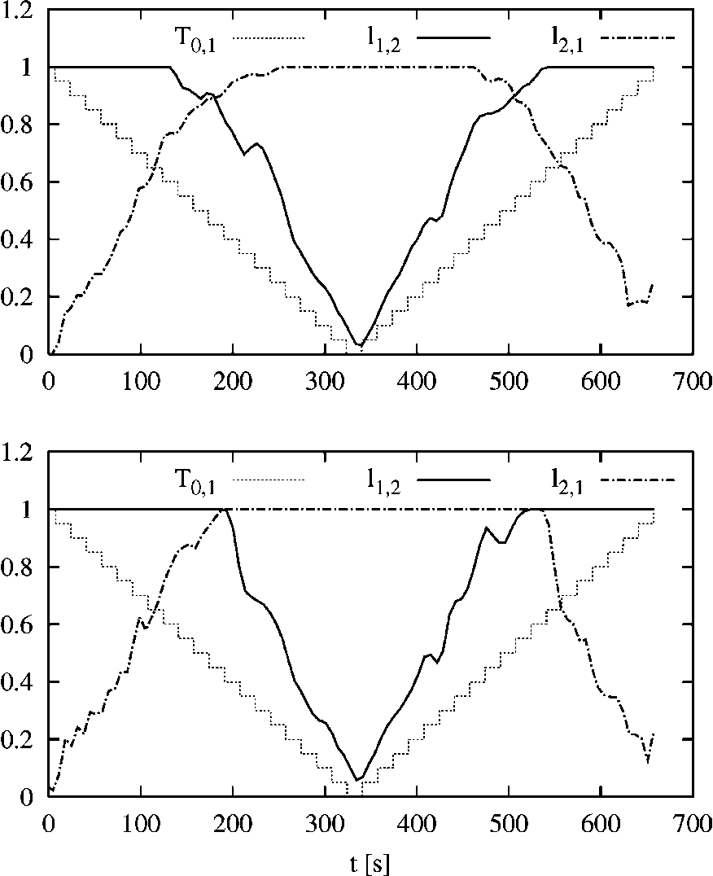
Fig. 2. Tri-node topology used to illustrate the elementary behavior of the routing algorithms.
Fig. 3. Free bandwidth on links e₁₂ and e₂₁ as the load shifts from traffic relation T₀₁ to T₀₂ and back: NGR-MD algorithm in the lower plot, MD algorithm in the upper plot.
classic MD algorithm (upper plot). Link loads are plotted versus the simulation time. The dotted, stepwise line is the fraction of traffic T₀₁; the fraction T_{0j2} is not shown but has a complementary profile. Ideally, traffic should never be routed on both links e_{1j2} and e_{2j1} at the same time, since this would entail that there is traffic flowing from v₀ to v1 through v2 and from v0 to v2 through v1, at the same time: it would be desirable to simply ''swap'' the traffic on the alternate paths so that links e₁₂ and e₂₎₁ are completely free, and they can be used to accommodate traffic among nodes v₁ and v₂.
Analyzing Fig. 3 it is clear that the NGR-MD algorithm achieves this result almost perfectly, while the MD algorithm displays transitions (around times 150 and 500), where both links are used at the same time, thus wasting resources. This phenomenon is at the root of the poor performance of MD (in fact, of any QoS-based algorithm) when the network load increases, due to frequent transients similar to the simple ones purposely generated in our example.
4.2. Performance on random topologies
In this section, we present results obtained on randomly generated network topologies using the GT-ITM software [18]. All topologies were generated using the ''flat random graph'' model, and include 32 nodes, with an average connectivity degree of 4. Every link has the same capacity (10 Mb/s), and there is a best-effort traffic source generator connected to each node, opening connections with a maximum bandwidth of 1Mb/s; each connection attempts to perform a bulk data transfer whose size is randomly chosen from an exponential distribution with average 2.5 Mb. Each node adopts a fixed update period for the QoS metric, set to 30 s. The simulator does not model the overhead resulting from signaling traffic.
To model the starvation effect [16], a starvation threshold B_{t} is set to 50 kb/s and used to identify starved connections: if the current per-connection bit rate estimate on a bottleneck link drops below Bt, then the most-backlogged connection on that bottleneck is picked and shut down. This is repeated until the sending rate of starved connections raises above the threshold. This allows us to define the starvation probability P_{s} as the ratio between connections that are prematurely aborted and the total number of connections that entered the network.
To get accurate results, each simulation was ended when the performance indices were such that the 95% confidence interval was within 2% of the point estimate.
We report results for two networks, named (A) and (B) for short. More simulations were ran on similar, random topologies, although they are not reported here for lack of space; they show results comparable to the ones reported in the paper, and thus similar conclusions can be drawn.
Results for network (A) reflect a simple stationary traffic scenario. A uniform traffic pattern is simulated, i.e., when a new connection request is generated, the source and the destination are randomly chosen with the same probability. All the sources have the same probability of generating a new connection. These probability are stationary, i.e., they do not change during the simulation.
On the contrary, results reported for network (B) refer to a more complex traffic pattern, mimicking a ''client-server'' scenario. Besides, the traffic matrix changes over time. In more detail, among the 32 nodes, 5 nodes, picked among those with the highest number of outgoing links, are defined as ''servers,'' while all the remaining one are defined as ''clients.'' Each server node generates 10 times the traffic generated from a client, with a non-stationary behavior: it randomly cycles over time between two states, high traffic and low traffic. When it is in the low-traffic state, it reduces its offered load by a factor of 10, i.e., it behaves as a client node. The average time spent in either the high- or low-traffic state is 3 h, following an exponential distribution.
4.2.1. Network (A)
Fig. 4 reports the average throughput obtained by single connections that have completed their information transfer. The upper plot reports the absolute value in kb/s versus the aggregate load offered to the network, expressed in Mb/s. The throughput is obviously decreasing with the net-
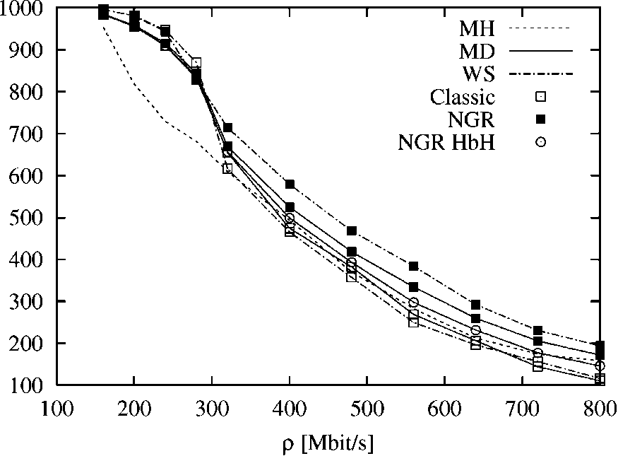
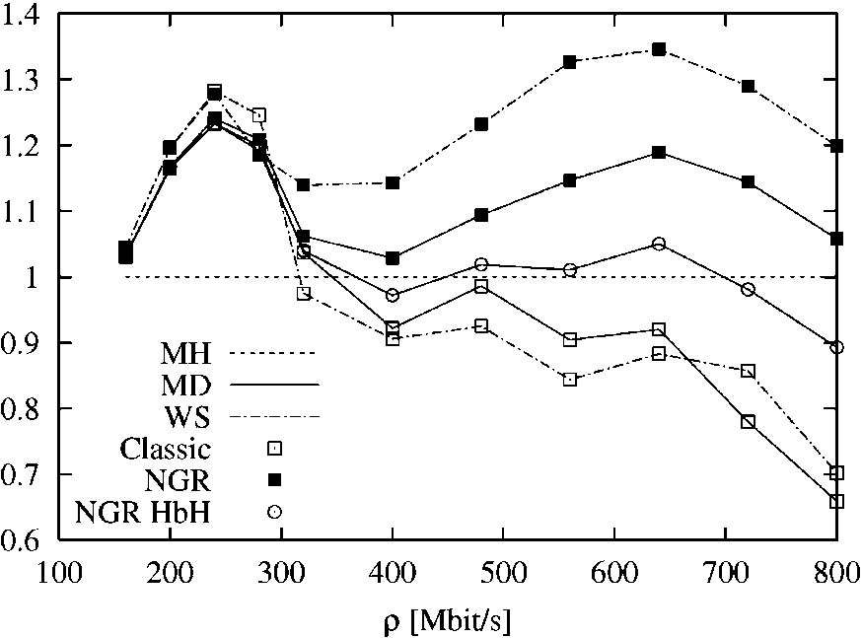
larger. Interestingly, the hop-by-hop implementation of NGR routing (NGR HbH) feature a performance midway between the consistent version and the classic algorithms, thus confirming that locally-optimal decisions are affected by performance degradation that limit the benefits of the NGR approach.
In addition, the NGR-WS algorithm performs better than the NGR-MD, since the path set it chooses from only includes minimum-hop ones. Indeed, the achieved gain is always larger than 15%. The non-monotonic relative behavior of the algorithms is due to the ''randomness'' of the topology that is neither regular nor a ''well defined'' hierarchical topology, which causes different portion of the network to become congested depending on the values of offered load, and on the specific QoS routing algorithm implemented.
One might wonder whether connections completing their information transfer obtain a larger throughput simply thanks to the larger number of starved connections shutting down, thus leaving more resources up for grabs. Figs. 5 and 6 shed some light on this issue. Fig. 5 reports the probability that connections close up because they are starved. NGR algorithms show a starvation probability that is between MH (the highest) and the classic MD and WS algorithms. In more detail, the starvation probability measured is negligible for all the QoS algorithms for values of the offered traffic
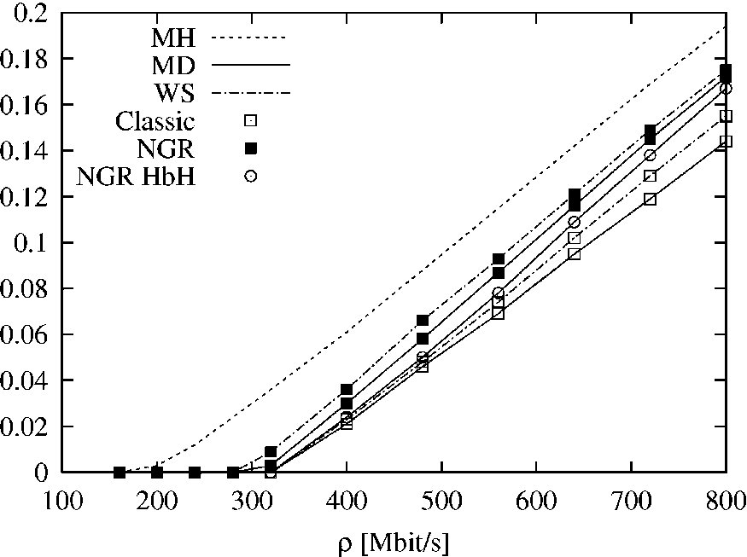
Fig. 5. Average starvation probability on network (A); uniform and stationary traffic pattern.
Fig. 4. Average per-connection throughput on network (A) with uniform and stationary traffic pattern; absolute value (kb/ s) (upper plot) and value normalized w.r.t. MH (lower plot).
work load for all routing algorithms, since the number of competing connections increases, and elastic connections adapt their sending rate according to a max-min fair-share algorithm.
The advantage of QoS routing algorithms over MH at low loads is clear, but while the classic MD and WS implementations fall below the MH at high loads, NGR algorithms always tops MH. The behavior is all the more evident if we take the throughput normalized with respect to MH (lower plot). This can also be seen as the gain of the algorithms as compared to the well-established, simple MH. It is clear that the MD and WS algorithms are extremely sensitive to the network load, while the NGR versions perform better than MH, converging to its performance as q grows
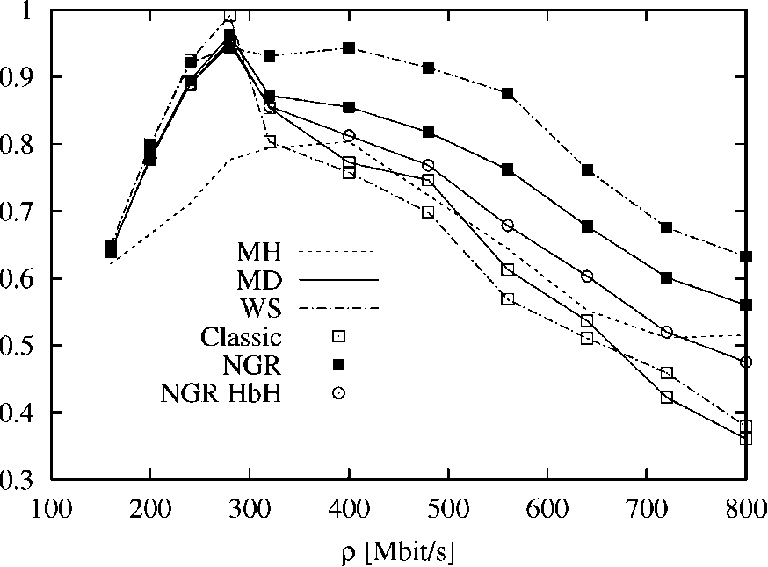
Fig. 6. Total network throughput on network (A); uniform and stationary traffic pattern.
smaller than about 300 Mb/s, while the MH algorithm shows an earlier increase in the starvation probability, at about 200 Mb/s of offered traffic. Then, a linear increase is shown by all the proposed algorithms.
Fig. 6, finally, reports the net total utilization of the network, i.e., the total amount of useful information carried by the network, normalized with respect to the total installed bandwidth. While all the QoS routing algorithms sport a better utilization of the network capacity at low values of offered load, the classic MD and WS algorithms show steep decreases in the throughput, mitigated by the NGR implementations, which shows the highest throughput, up to 30% larger than either MH, MD or WS algorithms.
4.2.2. Network (B)
In the case of the client-server model with non-stationary traffic, it is more interesting to separately look at client's and server's behavior, especially in view of the high level of traffic generated by the servers during their active cycles. Fig.
7 shows the average throughput per connection normalized to the one obtained by MH, while Fig.
8 reports the absolute values. The upper plot refers
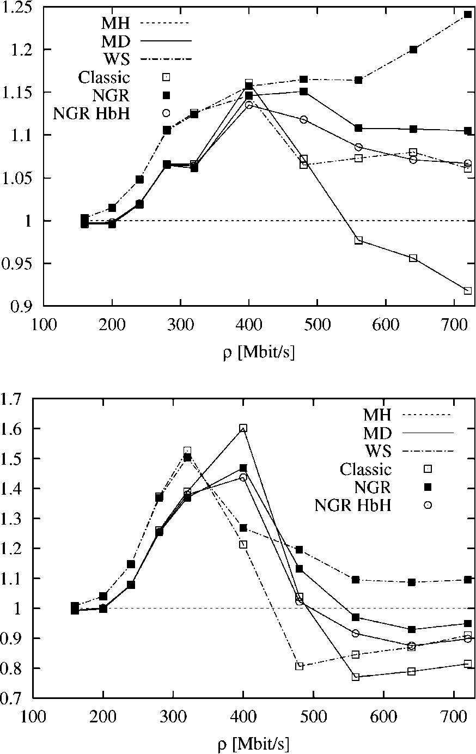
^{).}
⁴
⁴ The total installed bandwidth is simply defined as the sum of the capacity of all the links in the network.
Fig. 7. Per-connection average throughput (normalized w.r.t. MH) of clients (upper plot) and servers (lower plot) on network (B) with client-server, non-stationary traffic pattern.
to clients while the lower plots refer to servers. Also in this case the NGR version of the algorithms outperforms the classic QoS routing. The more complex nature of the traffic pattern which keeps changing during time, reduces the gain observed for the client connections to less than 20%. On the contrary, the performances obtained by server nodes are greatly improved by any QoS routing for relatively low load, with the classic MD showing a clear edge. But as soon as the network load increases over 500 Mb/s, their performance worsen, while the NGR versions still exhibit a better utilization of the network capacity.
Figs. 9 and 10 report the probability of starvation and the total network throughput (again,
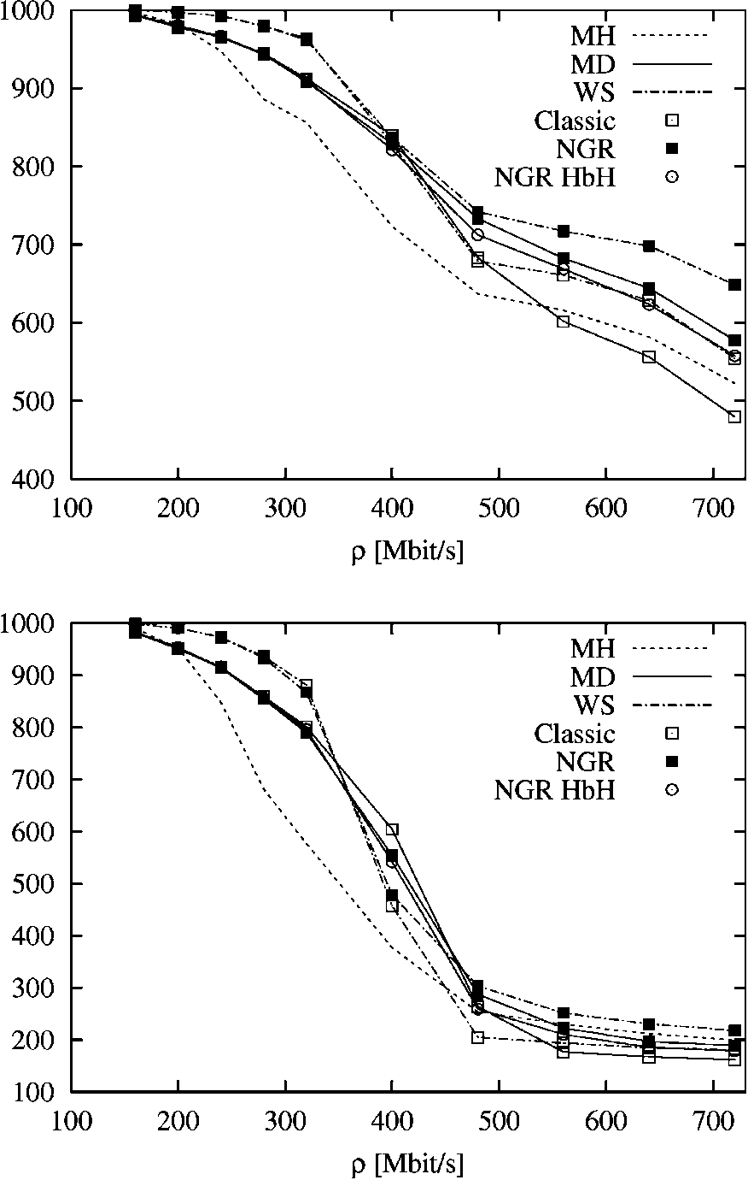
Fig. 8. Per-connection average throughput of clients (upper plot) and servers (lower plot) on network (B) with client-server, non-stationary traffic pattern.
only the useful portion of it) respectively; in both cases, results are averaged including both servers and clients. The starvation probability confirms results discussed about network (A). It shows that the use of QoS routing greatly reduces the starvation probability, reflecting a better distribution of the traffic on the network. Also in this case, the
NGR-MD and NGR-WS algorithms exhibit a
slightly higher starvation probability.
Considering the network throughput reported in Fig. 10, we can observe that the network capacity is not completely saturated by the offered traffic, at least during the period of time when the servers are in the low-traffic regime. Given the complex network topology and traffic pattern, it is very difficult to predict the performance, especially
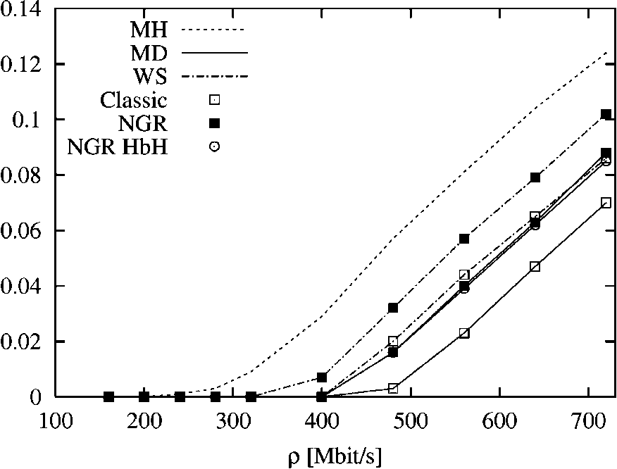
Fig. 9. Average starvation probability on network (B); client-server and non-stationary traffic pattern.
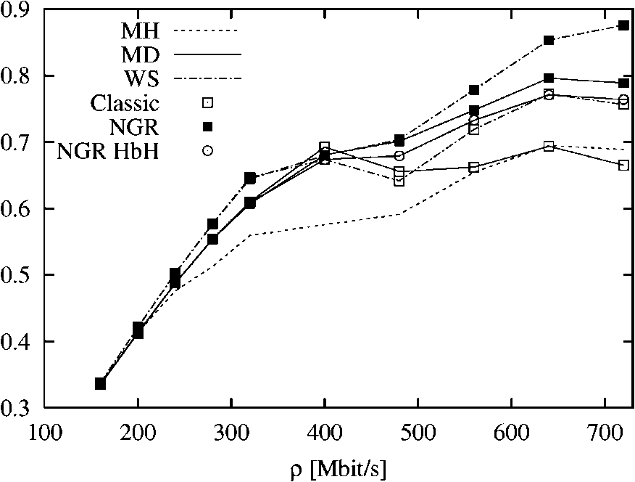
Fig. 10. Total network throughput on network (B); client-server and non-stationary traffic pattern.
for high values of the offered load. However, also in this case the best performance is obtained by the NGR algorithms.
5. Discussion and work evolution
The search for efficient and robust routing algorithms that can replace the traditional MH routing used in TCP/IP networks has received, and is still receiving, considerable attention; however, so far, none of the proposals seems to offer enough benefits to counter-balance the necessarily increased complexity. In particular, robustness to changes in traffic pattern and, most of all, to sudden load increases is a major concern, since all QoS-based algorithms seem to perform worse than the simple MH algorithm as the network load increases.
Since the optimality of MH routing can be demonstrated under some simplifying assumptions, and can be inferred under more realistic scenarios, a robust and resilient routing algorithm should converge to the MH routing as the traffic load grows larger and larger.
Pursuing this idea, in this paper we have proposed and discussed a new class of routing algorithms that exhibit this property and that are shown to outperform both the MH and traditional QoS-based algorithms in simulation. These routing algorithms are based on a technique which reduces the graph describing the network to a graph containing only uncongested links. The selection of the path is then performed on a set containing paths evaluated on the reduced graph, plus the minimum-hop path itself. In their consistent form, these routing algorithms cannot be implemented by a standard hop-by-hop procedure, but require either the use of MPLS techniques, or a (simple) modification of the IP forwarding. Simulation results, as well as intuition, have shown that a locally-optimal hop-by-hop implementation of these algorithm is liable to performance degradation, while still retaining some advantages over classical algorithms.
Further research in this area should address the possibility of finding a similar class of routing algorithms that are, however, implementable in a hop-by-hop fashion without requiring any modification to the standard IP forwarding.
[4] D. Cavendish, M. Gerla, Internet QoS routing using the Bellman-Ford algorithm, in: High Performance Networking (HPN98), IFIP, Vienna, Austria, 1998.
[5] G. Apostolopoulos, R. Guerin, S. Kamat, S.K. Tripathi, Quality of service based routing: a performance perspective, in: ACM SIGCOMM'98, Vancouver, Canada, September 1998.
[6] G. Apostolopoulos, D. Williams, S. Kamat, R. Guerin, A.
Orda, T. Przygienda, QoS Routing Mechanisms and OSPF
Extensions, RFC 2676, August 1999. [7] A. Shaikh, J. Rexford, K. Shin, Load-sensitive routing of
long-lived IP flows, in: ACM SIGCOMM '99, Cambridge,
MA, August 1999, pp. 215-226. [8] J. Moy, Open Shortest Path First version 2, RFC 2328,
April 1998.
[9] Ross Callon, Use of OSIIS-IS for Routing in TCP/IP and Dual Environments, RFC 1195, December 1990.
[10] D. Bertsekas, R. Gallager, Data Networks, second ed., PrenticeHall, Englewood Cliffs, NJ, 1992.
[11] S. Sibal, A. De Simone, Controlling alternate routing in general-mesh packet flow networks, in: ACM SIGCOMM '94, London, UK, August 1994.
[12] J.L. Sobrinho, Algebra and algorithms for QoS path computation and hop-by-hop routing in the Internet, IEEE Transactions on Networking 10 (4) (2002) 541-550.
[13] C. Casetti, G. Favalessa, M. Mellia, M. Munafo, An adaptive routing algorithm for best-effort traffic in inte-grated-services networks, in: Sixteenth International Tele-traffic Congress (ITC-16), Edinburgh, UK, June 1999.
[14] E. Rosen, A. Viswanathan, R. Callon, Multi-Protocol Label Switching Architecture, RFC 3031, January 2001.
[15] C. Casetti, R. Lo Cigno, M. Mellia, M. Munafo, Z. Zsoka, Routing algorithms evaluation for elastic traffic, in: IEEE Workshop on High Performance Switching and Routing (HPSR 2001), Dallas, Texas, May 29-31, 2001.
[16] C. Casetti, R. Lo Cigno, M. Mellia, M. Munafo, Z. Zsoka, A realistic model to evaluate routing algorithms in the internet, in: IEEE Globecom 2001, San Antonio, Texas, November 25-29, 2001.
[17] ANCLES—A Network Call-Level Simulator. Available from: <http://www.telematics.polito.it/ancles>.
[18] GT-ITM Georgia Teach-Internetwork Topology Models. Available from: <http://www.cc.gatech.edu/projects/gtitm>.
References
[1] Z. Wang, J. Crowcroft, QoS routing for supporting multimedia applications, IEEE JSAC 14 (7) (1996) 1228-1234.
[2] Q. Ma, P. Steenkiste, H. Zhang, Routing high-bandwidth traffic in max-min fair share networks, in: ACM SIG-COMM'96, Stanford, CA, August 1996, pp. 206-217.
[3] Q. Ma, P. Steenkiste, Routing traffic with quality-of-service guarantees in integrated services networks, in: Eighth IEEE/ACM International Workshop on Network and Operating Systems Support for Digital Audio and Video (NOSSDAV98), England, July 1998.
Claudio Casetti graduated from the Politecnico di Torino with a Master's degree in Electronic Engineering in 1992 and a Ph.D. in Electronic and Telecommunication Engineering in 1997. He was a visiting scholar at the University of Massachusetts at Am-herst in 1996 and at UCLA in 2000. He is currently holding an Assistant Professor position at the Dipartimento di Elettronica e Telecomunicazioni of Politecnico di Torino. He has coau-thored about 40 journal and conference papers in the area of communication networks. His interests are in the field of performance evaluation of TCP/IP networks and multimedia communications.


Renato Lo Cigno was born in Ivrea, Italy in 1963. He received a Dr. Ing. degree in Electronic Engineering from Politecnico di Torino in 1988. Since then he has been with the telecommunication research group of the Electronics Department of Politecnico di Torino, first as Research Engineer and then as Assistant Professor. Starting November 2002 he holds a position as Associate Professor at the University of Trento, Italy.
From June 1998 to February 1999, he was at the CS Department at UCLA as Visiting Scholar under grant CNR 203.15.8. He is coauthor of about 80 journal and conference papers in the area of communication networks and systems. He was in the program committee of IEEE Globecom and IEEE ICNP.
His current research interests are in performance evaluation of wired and wireless networks, modeling and simulation techniques, QoS management including routing and congestion control.
Marco Mellia was born in Torino, Italy, in 1971. He received his degree in Electronic Engineering in 1997, and a Ph.D. in Telecommunications Engineering in 2001, both from Politecnico di Torino. From March to October 1999 he was with the CS department at Carnegie Mellon University as visiting scholar. Since April 2001, he is with Electronics Department of Politecnico di Torino as Assistant Professor. His research interests are in the fields of: All-Optical Networks, Traffic measurement and modeling, QoS Routing algorithms.


Maurizio Munafo is Assistant Professor in the Electronics Department of Politecnico di Torino. He holds a Dr. Ing. degree in Electronic Engineering since 1991 and a Ph.D. in Telecommunications Engineering since 1994, both from Politecnico di Torino.Since November 1991 he has been with the Electronics Department of Politecnico di Torino, where he has been involved in the development of an ATM networks simulator.
He is coauthor of about 30 journal and conference papers in the area of communication networks and systems. His current research interests are in simulation and performance analysis of communication systems and QoS routing algorithms.
Zoltan Zsoka was born in Budapest, Hungary, in 1975. He received his M.Sc. degree in Informatics in 1999 from the Budapest University of Technology and Economics. Currently he is doing his Ph.D. studies supervised by Ldszlo Jereb at the same university. In 1999 and 2001 he was with the Electronics department at Politecnico di Torino, Italy, performing research activities as visiting scholar. His research interests are in the fields of All-Optical Networks, Network Performance studies and QoS Routing algorithms.


